**Aim**

To design and deploy a **Car Booking Reservation System** on a cloud platform (Zoho Creator) to demonstrate **Software as a Service (SaaS)**, where customers can book cars and administrators can manage reservations online.

**Procedure**

**Step 1: Login to Cloud Provider**

* Open Zoho Creator and log in with your Zoho account.

**Step 2: Create a New Application**

* Click **Create Application → From Scratch**.
* Name the app: **Car Booking Reservation System**.

**Step 3: Build Forms (Input Screens)**

1. **Car Details Form**
   * Car ID (Auto-number)
   * Car Model (Text)
   * Car Type (Dropdown: Sedan, SUV, Hatchback, etc.)
   * Availability Status (Dropdown: Available / Booked)
   * Price per Day (Number)
2. **Customer Booking Form**
   * Customer Name (Text)
   * Email (Email)
   * Phone (Phone)
   * Car (Lookup from Car Details Form)
   * Booking Start Date (Date)
   * Booking End Date (Date)

**Step 4: Create Reports (Data Views)**

* **Available Cars Report** → Shows cars with status = Available.
* **Booking Report** → Lists all customer reservations with details.

**Car Booking Reservation SaaS Application:**

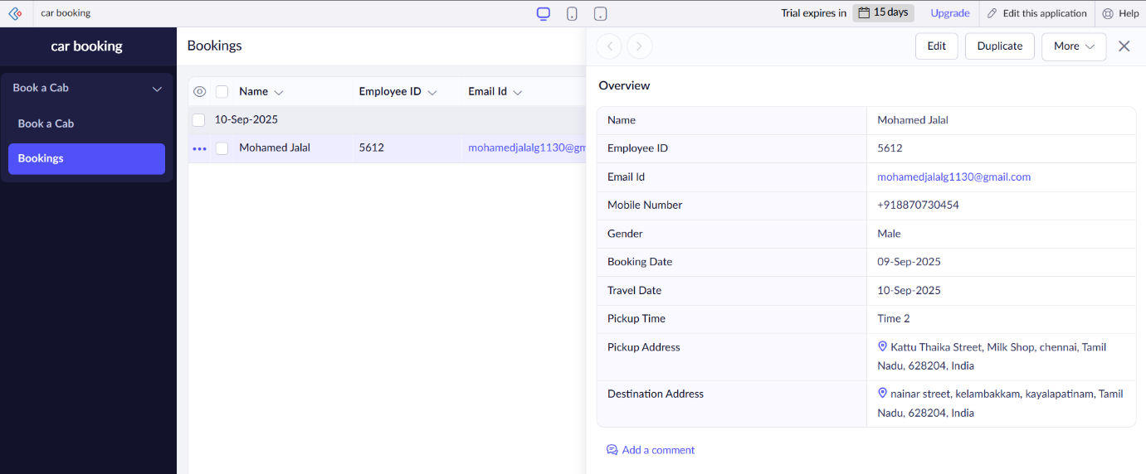

**Result**

* A **Car Booking Reservation SaaS Application** was successfully created and deployed on **Zoho Creator**.
* Customers can view available cars, book them for a date range, and receive booking confirmations.
* Car availability is automatically updated in the system.
* The app is **hosted on Zoho’s cloud platform** and accessible via the internet, fulfilling the definition of **Software as a Service (SaaS)**.